Twitter for zombies

CRUD : Create, Read, Update, Delete

b[:key] = “value”

Read

t = Tweet.find(3)
where Tweet automatically looks up in the tweets db

puts t[:id] = 3 =>hash syntax

puts t.id = 3 =>DB syntax for rails

Tweet.find(3,5,6)
Tweet.first = Tweet(3)

Create

t = Tweet.new
t.status = “I love brains”
t.zombie = “zombo”
t.save

OR

t = Tweet.new(
status = “I love brains”,
zombie = “zombo”
)
t.save

Update

t = Tweet.find(1)
t.status = “New status”
t.save

t = Tweet.find(1)
t.attributes(
status: “New status”,
zombie: “Zomber”
)
t.save

t = Tweet.find(1)
t.update(
status: “New status”,
zombie: “Zomber”
)

Delete

t = Tweet.find(3)
t.destroy

t = Tweet.find(3).destroy

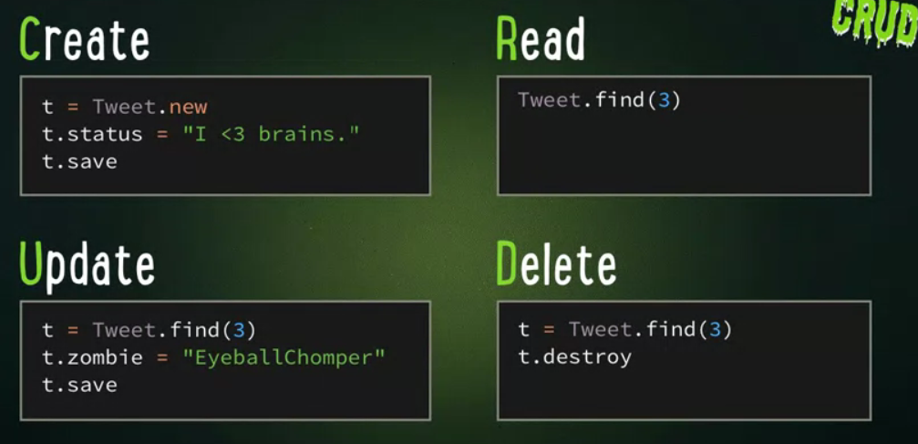

Tweet.count
=> return total number of tweets

Tweet.order(:zombie)
=> return tweets ordered by zombie

Tweet.limit(10)
=> return first 10 tweets

Tweet.where(zombie: “ash”)
=> return tweets of the zombie named ash

Method chaining

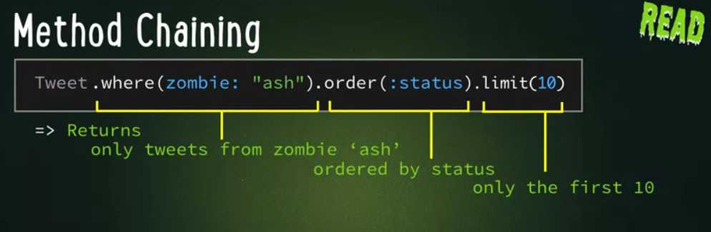
Method chaining makes rails very powerful over PHP for example

Models

You are able to work on the class Tweet in the previous section because it has been defined in the model

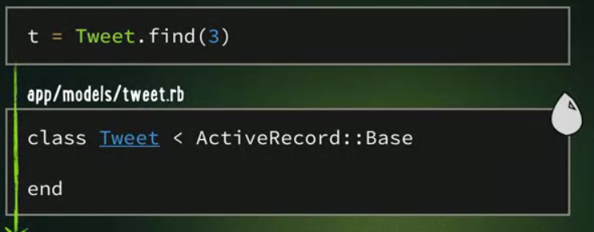
Tweet is an extension of the databse

Model validation
If you wanna make sure that a new entry is not blank, use the validates_presence_of :key method

class Tweet < ActiveRecord::Base
validates_presence_of :status
end

A few other validation methods:
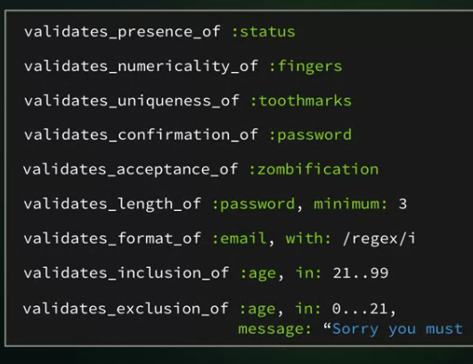

You can also customize them

validates :status,
uniqueness:true, presence:true
length: {minimum:3}

The first word is the paramater to validate: here it is status, and the following lines are on what grounds to validate it
Relationships

Linking keys:

a zombie has several tweets, a tweet has only one zombie
=>
class Zombie
has_many :tweets
end

class Tweet
belongs_to :zombie
end

The relationship is created, you can now create tweets that will automatically link to the cooresponding zomb in zombie table
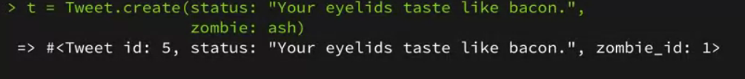
ash.tweets will return an array with all the tweets

Views

Ruby integration in html:
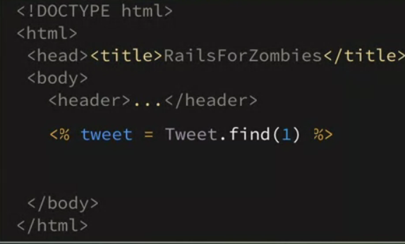
<%= printing out ruby %>

linking view and show view:
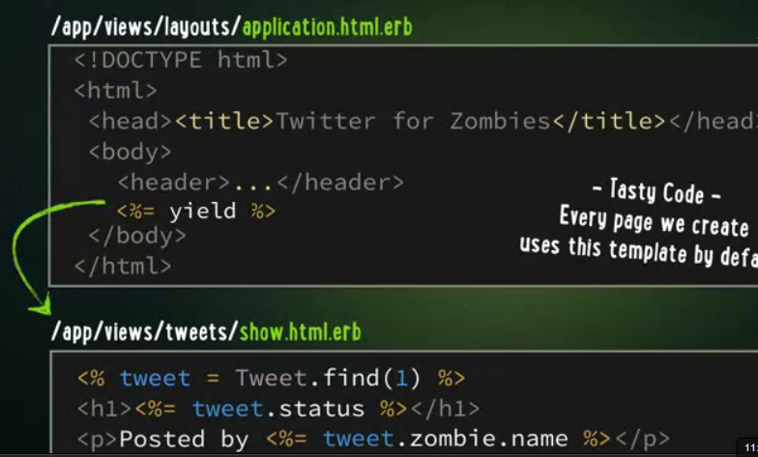

Create a link

<?php foreach tweets as tweet:>
html code
<?: endforeach?>

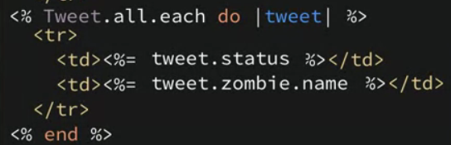

Empty Table?

How do we show no tweets found instead? We create a variable tweet equal to all.Tweets and if it is equal to 0, prints our our error message, which we add after our standard code

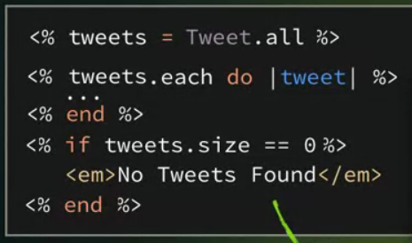

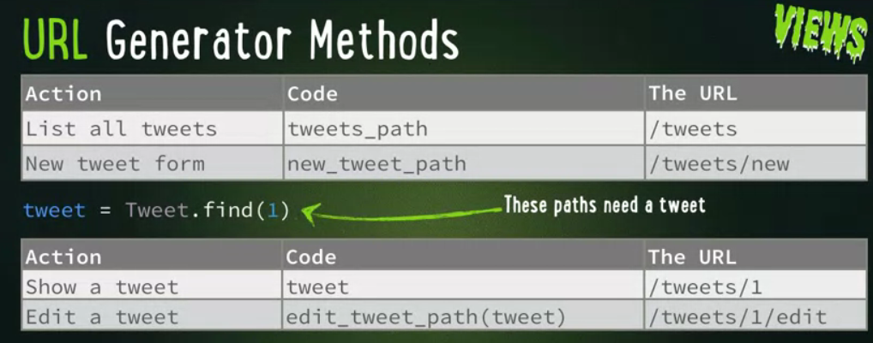

Controllers

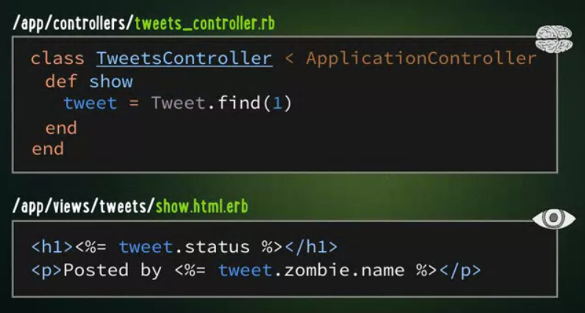
Here, the def show directly refers to the view called show.html.erb

This is an equivalent of GET in rails (params):
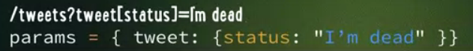
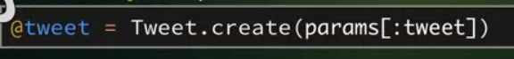
This code is dangerous, as with any get method. We are going to secure it by asking for validation if the tweet exists:
What if request is in json or xml format? You need to specify in the controller the formats you want to accept
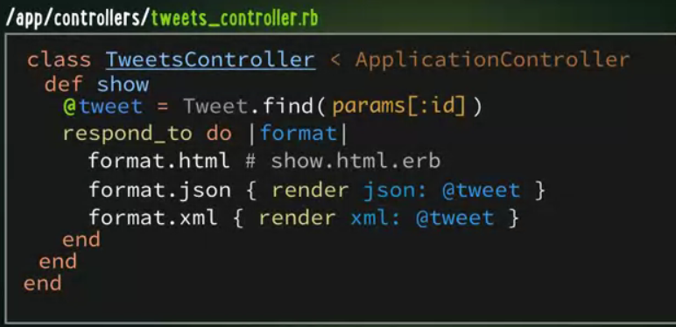
Typical controller:
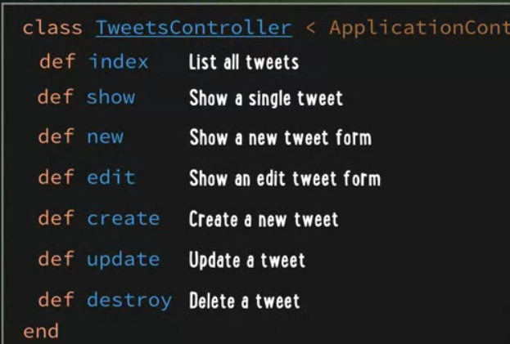
Do we need to implement these methods one by one? Are they pre-programmed in rails? God fucking knows. And the best part is you actually have to pay if you wanna advance in those tutorials. Fucking disgrace.

Authentification

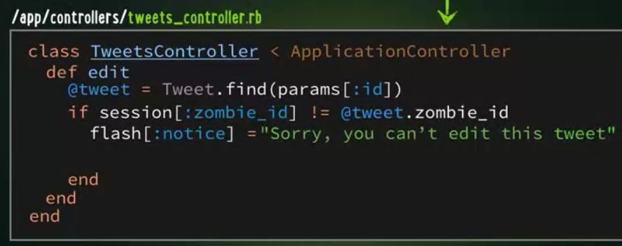
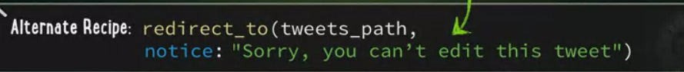

Routing

All the routing is treated as an extension class of object tweet

